Publication for the

Philips MRI Community

**Issue 44 – SUMMER 2011**

Metal artifact reduction for MRI of metal

prostheses and implants Contributed by Marius van Meel, MR Application, Best, The Netherlands

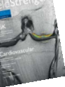

This article is part of FieldStrength issue 44

**Summer 2011**

**18** Application tips

Contributed by **Marius van Meel,** MR Application, 

Best, The Netherlands

Metal artifact reduction for MRI of metal prostheses and implants*

Patients suffering from pain after receiving hip or knee implants may have soft tissue disease. MRI is ideal for soft tissue sensitivity, but the metal implant causes magnetic field disturbances leading to an artifact which complicates image interpretation. Metal artifact reduction sequences (MARS) are less

sensitive to metal artifacts. These tips show how to adapt your scans to reduce the metal artifacts. ExamCards will be available on NetForum shortly.

*See note on bottom of page 21

**TIP 1**

Use TSE instead of FFE

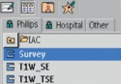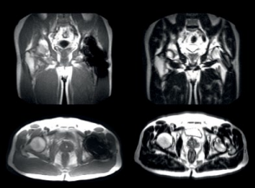

TSE will show less pronounced metal

artifacts than gradient echo sequences

(FFE and TFE), because of the refocusing

pulses used in TSE.

So, use preferably TSE sequences instead

of FFE. Also use a TSE survey – an

example can be found in the IAC preset

protocols:

18 FieldStrength - Issue 44 - Summer 2011

TFE: strong metal artifact TSE: less metal artifact

**TIP 2 TIP 3**

SENSE or CLEAR Use short echo spacing and high TSE factor

Switch off SENSE and CLEAR; Select no in the Geometry tab. Without SENSE or CLEAR, the reference scan can also be removed from the ExamCard to save scan time.

Nowadays, asymmetric TSE allows more direct control of ES, and the TSE factor can be increased to speed up the scan. Don’t make the TSE shot larger than about 4 x TE to avoid blurring. In older releases with linear profile order, a short echo spacing (ES) could be only obtained by setting a high TSE factor.

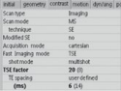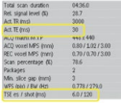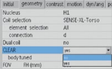

**TIP 4**

Use a small WFS of 0.5 to 0.7

Use a small WFS of 0.5 to 0.7; this 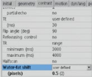

corresponds to a high bandwidth.

For more explanation, see application

tip in FieldStrength issue 36, Dec. 2008.

These low WFS values require strong

gradients, so use gradient mode maximum.

If you still can’t reach the low WFS,

then you may set it to minimum. It is

not recommended to do this from the

beginning, as WFS may become lower than needed, which leads to low SNR.

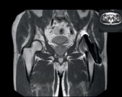WFS 2, bandwidth 110 Hz/pixel 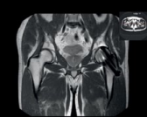WFS 0.5, bandwidth 440 Hz/pixel

CONTINUE

FieldStrength 19

**TIP 5**

Use thin slices 

Selecting thin slices will need a strong slice selection gradient, which

is similar to setting a high bandwidth for the readout, and thus will

decrease through-plane artifacts, as seen in this example.

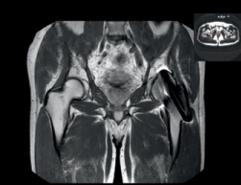Voxels 0.8 x 1.0 x 6 mm 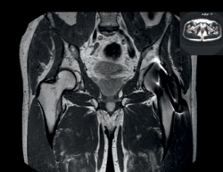Voxels 0.8 x 1.0 x 3 mm

**TIP 6**

Maintaining good SNR

Increase NSA to compensate when measures of the previous tips cost some SNR. The typical scan time of

a MARS protocol is about 5 minutes. If you want to further increase SNR, give up some in-plane resolution first.

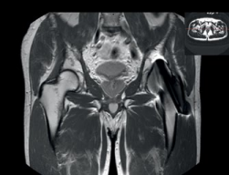 Standard PDW TSE MARS – everything together Achieva 1.5T with 32-channel SENSE Cardiac coil.

PDW TSE with asymmetric profile order, ES 6 ms, TSE factor 20, WFS 0.5,

voxels 0.8 x 1.0 x 2.0 mm, no SENSE, no CLEAR, NSA 3, scan time 4:54 min.

20 FieldStrength - Issue 44 - Summer 2011

**TIP 7**

Use STIR, no spectral fat saturation

Use STIR for fat suppression. This is implemented in the MARS

ExamCards on NetForum, fitting the scan in one package for 1.5T

or two packages for 3.0T. Do not use spectral fat saturation such

as SPIR or SPAIR, because these techniques perform best in a

homogeneous magnetic field.

SPAIR STIR

**TIP 8**

Gradient echo images

Sometimes, gradient echo (FFE or TFE) may be needed and cannot be replaced by TSE. Note that in such cases principles as outlined in the previous tips still apply.

**Disclaimer**

Metal implants are a contraindication for MRI, unless the MR compatibility for the implant is stated by the implant manufacturer. MR healthcare professionals are advised to contact the respective implant manufacturer in order to obtain the latest safety information to ensure patient safety relative to the use of an MR procedure.



**NetForum** www.philips.com/netforum

1.5T and 3.0T MARS ExamCards for hip and knee will soon be available for download from

NetForum.

View additional information:

www.revisemri.com/blog/2011/ metal-artefact-reduction/

FieldStrength 21